**Formatting with tables, charts and pictures**

* Inserting a Table

Tables may be easily added to a text document.

1. Place cursor in document where you want to insert the table.
2. Click the **Insert tab**
3. In the **Tables** group, select dropdown menu.
4. Select **Insert Table** from the resulting menu.
   1. In the **Table Size** section, enter the number of columns and rows.
   2. *Optional:* Select options in the **AutoFit behaviour**
5. Click **OK**

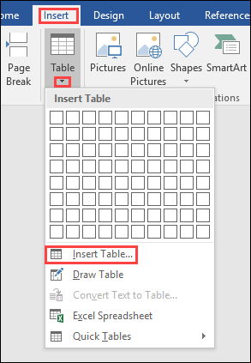**Note: To quickly insert a table, click the Table button in the Tables group and drag to select the number of rows and columns. Click in last selected cell of grid to insert Table.**

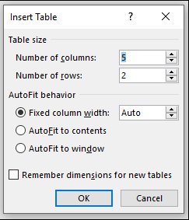

* Converting Text to Table

**Sometimes text in a document may be better illustrated as a table. To convert existing text to a table:**

1. Highlight text to be converted to a **Table**
2. Click the **Insert** tab >**Table>** **Convert Text to Table>**dialog box opens
3. Complete fields for options: **Table Size, Auto fit** and **Separation character**
4. Click **OK**

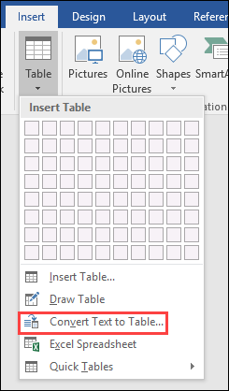

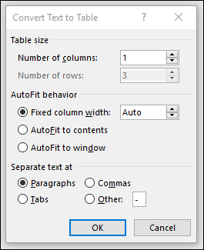

Inserting a Picture:

Pictures and graphics add punch to your document, but remember not to overdo them! They are there to enhance your information, not eclipse it!

1. Place cursor in the document where you want to insert the item
2. On the **Insert** tab, in the **Illustrations** group, do one of the following:

* ***To insert a Picture from a file****:* select **Picture**. Locate and select the file you want to insert from your computer and click the **Insert**
* ***To insert an Online Picture****:* select **Online Pictures**. In the task pane, enter a keyword in the **Search** box and click the **magnifying glass icon**. Select desired image and click
* ***To insert a Shape:*** click the **Shapes** dropdown menu. Select the **Shape** you want from the resulting menu. Click and drag in the document to create the **Shape**.
* ***To insert a SmartArt Graphic:*** select **SmartArt**. Select the desired **SmartAr**t graphic from the menu. Click **OK**.
* ***To insert a Screenshot:*** select **Screenshot** button.  To insert a screen that you have open on your computer, select the screen from the **Available Windows.** To create your own screenshot, select **Screen Clipping.**  Click and drag the area of your 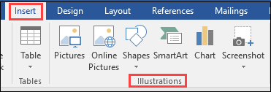screen you want to insert.

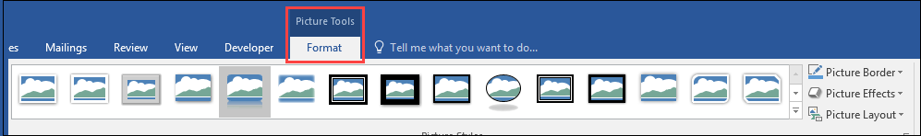

Inserting a Chart or Graph

1. On the **Insert** tab, in the **Illustrations** group, click **Chart**.
2. Select the type of chart desired and click **OK**.
3. 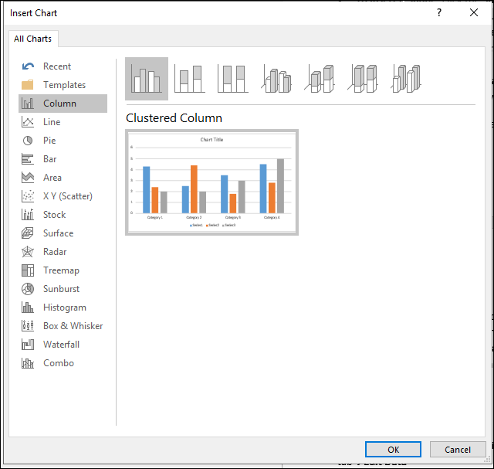Edit the data in the **Excel** sheet that opens with the **Chart.** When you are finished editing the data, close the data sheet.

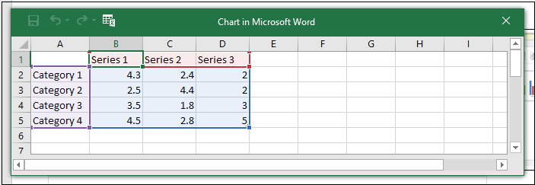

Changing data in an existing chart:

1. Select the **Chart** in your document
2. In the **Chart Tools** contextual tab in the **Ribbon**, select **Design** tab>**Edit Data**
3. A data spreadsheet will open; make desired changes

